Mission: Provide continuous radio communications for the Lovettsville Oktoberfest event on Saturday, September 24, 2016. We will be providing the primary essential communication “dispatch” function for the township, police and fire. Net Control will be located in Town Hall and the LARG Operations tent will be located at the library.

Reference: Safety plan issued by Mayor Zoldos

Hours of operations:

Net Control: 07:00 to 18:00 (or until event officially over)

Location: Town Hall 6 Pennsylvania Ave, Lovettsville, VA 20180 (Trailer)

LARG Booth/Tent: 07:30 to 17:00 Adjacent to the Aid Station located at Town Center

Procedures:

NOTE: THIS IS A RAIN OR SHINE EVENT. THERE IS A 100% CHANCE THAT THE EVENT WILL TAKE PLACE AND SLIM CHANCE OF RAIN OR ANY SIGNIFICANT WEATHER. THE NCS WILL RUN 100% OF THE TIME ON ALL BANDS IN ANY WEATHER INCLUDING A THUNDERSTORM, UNLESS AN EVACUATION ORDER OR SHELTER IN PLACE ORDER IS GIVEN.

For reference, the “shelter in place” locations are: BB&T, ST. James Church, Town Office (near main tent), and the Lovettsville Museum.

Communications will take place on a directed voice net. All communication will be on the primary frequency unless directed by net control to secondary frequencies for the handling of traffic. The net control will be located at the trailer behind Town Hall, 6 Pennsylvania Ave, Lovettsville, VA 20180. Net control will use the call sign of K4LRG. You will address the NCS as “NET”. Occasionally NCS will identify K4LRG on the primary frequency. You will use your call sign when contacting NCS.

The net primary frequency will be simplex 147.480 MHz, no tones. This will be the only requirement for you as a volunteer unless you are operating as network control (see below).

NO REPEATERS WILL BE USED FOR THIS EVENT.

Town Frequency - The town of Lovettsville will use Virginia Radio Cache radios. Programming for the radios will be 46-November. Only net control will be required to operate on the VA Cache system. Sheriff radio and procedure will be determined morning of the event. LARG will issue the radios to the volunteers and check them back in.
Fire/Police Frequency - We will have a VA Cache radio to reach out to Fire/Rescue. Fire/Rescue will be monitoring 46-November. Sheriff radio and procedure will be determined morning of the event. Only net control will be required to operate on the Loudoun County system.

Contacting Net Control via the Public Phone Network:

A list of phone numbers will be attached to this document. If there is a need to contact net control and you are for whatever reason out of radio contact please use this list and your cell phone to contact the person responsible to dispatch information as required.

NOTE:

IN AN EMERGENCY WHERE SOMEONE IS CRITICALLY INJURED OR THEIR LIFE OR THE LIFE OF OTHERS IS THREATENED PLEASE CALL 911 FIRST THEN CONVEY THIS INFORMATION TO NET CONTROL. IF SOMEONE CALLS NET CONTROL WITH A LIFE THREATENING EMERGENCY 911 WILL BE CALLED IMMEDIATELY AND WE WILL COORDINATE EMERGENCY SERVICE THE BEST WE CAN FROM NET CONTROL TO THE SCENE IN QUESTION.

It is possible that 911 calls may get routed by the cell network to Frederick County instead of Loudoun County if you are on a Frederick cell tower. The suggestion in the event of making a 911 call, verify you are connected to Loudoun 911 or request transfer to Loudoun 911. This will expedite getting help to you.

ALL OPERATORS:

Please check in at Net Control located in Town Hall when you arrive where you will receive instructions.

There will be essentially five roles during the event. 1) network control operations, 2) scribe to take notes on all traffic directed by the net, 3) frequent patrol of the event area, 4) frequent patrol of the trolley stops, 5) issuing radios to volunteers.

The weather is expected to be very nice with temperatures in the low to mid 80’s If you have a red shirt or, a red LARG hat and shirt from previous events, please wear them.

Bring a chair to sit in the case there is not one already there for you.

For your radio:

    - Hand Held 2m pre-programmed for 147.48 simplex
    - Good antenna
    - Spare Battery

Schedule:

Oktoberfest set-up starts at 10:00. We plan on being on site at 06:30. Several people have volunteered to be on site a little early at 07:00 to set up and get ready for traffic by 08:00. Vendors are scheduled to set up between 8:00-10:00. Things will be “crazy” during that time and will taper off around noon as things get under full swing.

The weather is expected to be excellent. An above average turnout is expected.

NET CONTROL

Net control will establish the net at 08:00 and will begin station check in at that time. All volunteers should remain operational until told to secure by net control or check out with net control for the day.

LOGS:

A log of all traffic will be kept as current as reasonably possible and will be turned in to the Oktoberfest organizers for the traffic that was passed and handled. The primary scribe method will be by computer provided at NCS.

LARG Member Participation

See spreadsheet below for a list of participants.

EPILOGUE

One last request: Please take photographs! We will be putting together a section on the event which will be published to the public. Even if it’s one photograph with a few words it will be very beneficial to put on the web.

If you have any questions don’t hesitate to contact me. E-mail is ok (geeper88@gmail.com), but if you need a quick answer please call my cell phone number given here. 703-346-8565.

LARG Member Participation:

Name | Call | Cell Phone Number | Time | email
Ken Sullivan | KJ4GYL | 703-346-8565 | All Day | geeper88@gmail.com
John Westerman | W5ODJ | 703-431-9148 | All Day | john@packetwhisper.com
Luther Guise | K5NOB | 940-452-5304 cell | AM | k5nob@yahoo.com
Paul Dluehosh | N4PD | 571-233-8578 | All Day | N4PD@arrl.net
Denny Boehler | KF4TJI | 703-727-9427 | 7:00-Noon | dncboehler@verizon.net
Chris Patton | W3CUM | 202-445-1575 | 6:00am-3:00pm | c.patton@me.com
Nycole Klein | N3CLE | 571-830-1115 | Noon-3:00pm
Tina Hawley | KY4CMH |  | 7:00am-2:00pm | tina.hawley@yahoo.com
Frank Gentges | K0BRA |  | 3:00pm-6:00pm | fgentges@mindspring.com
Margaret Gentges | AI4UX |  | 3:00pm-6:00pm

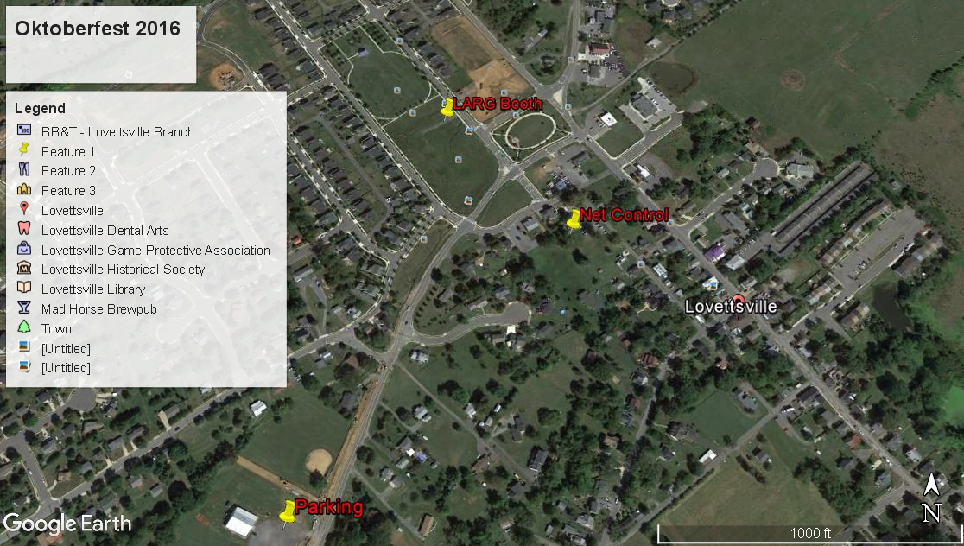

LARG Booth/Tent-Rovers based here.

Town Hall- Net Control--Come here first.

Parking-Game Club Located on left as you are coming North on 287 and just before you reach town. It will be marked with signs for the festival. Park here and take the trolley (or walk if you want the exercise).

